Sponsorship Proposal and
Marketing Plan
European Laser Quest Championships 2003

Sport for a New Era


Laser Quest and the ELC
Background information for readers

About Laser Quest

It’s a Laser game, right?
Laser Quest is an example of what is known as “laser tag”. The idea of the game is to tag your opponents with a laser beam to score points. At the most basic level, it is an all-against-all, highest-score-wins game, but systems such as Laser Quest enable many different types of games including team games, limited lives games and capture the flag scenarios.
Games are set in huge, specially designed multi-level mazes featuring ramps, catwalks, lighting effects, swirling fog and heart-pounding music. Players carrying laser guns and wearing vests fitted with sensors seek each other out, trying to score points for themselves and their team.
Popular for everything from corporate events and team building exercises through to birthday parties and casual entertainment, laser tag centres have sprung up in many towns and cities over the last ten to fifteen years.

So what about Laser Quest?
The world’s first Laser Quest centre opened in Manchester in 1989 and was well received following the launches of other laser tag games. Since then Laser Quest has spread around the globe to such an extent that there are approximately 150 centres in 17 countries.

Nowadays laser tag games are fairly commonplace, however the original Laser Quest system was one of the first to be designed. In the following years it received regular hardware and software upgrades and improvements and, in the mid-1990’s, it underwent a major redesign to make it one of the most superior laser tag systems available.
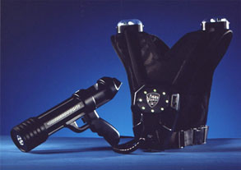
Laser Quest’s “LQX” equipment

After the concept proved to be a huge success in the UK, with 50+ centres open, attention turned to North America where other laser tag systems already existed. Laser Quest proved to be such a success in the North American market that the whole company moved to Canada. Today, all bar one of the centres in North America is directly owned by the Versent Corporation (CA:VTC, formerly Laser Quest Corporation). The number of centres in North America is still growing and it is proving to be as popular as ever.
Whilst the number of centres in the UK has fallen in recent years, it is enjoying a new lease of popularity and 2003 sees the opening of at least two new centres. Laser Quest has spread to the Far East and is widely played in France and Holland, among other countries.
It says much for Laser Quest that the brand has become synonymous with the laser tag genre.

About the ELC

Competitive Laser Quest
Laser Quest is not just about birthday parties and corporate team-building exercises, however. There are many people who, after playing for the first time at such an event, enjoy the experience so much that they play on a more regular basis. These people often become “members” at their local site and come to take the game much more seriously than the average customer. They can play in members’ leagues and in special members’-only events, which involve more complicated and varied game types.
A centre may organise a tournament, to which they invite other centres to send teams and players, and teams from one centre may challenge another centre to a match. Whilst there has never been a formal “league” in the UK, there have always been such ad-hoc matches taking place. However, for some people, this was not enough.

The European Championships
The European Laser Quest Championships is the chance for teams from all over Europe to show off their skills and find out exactly how good they really are. The idea was first conceived by two members of the Guildford team “The Tribe Called Quest”, after they travelled to Holland to participate in a round of the Dutch Open Laser Quest Championship. They, along with the captain of the Woking team, wanted to bring the best European players together to decide who, in fact, had the right to call themselves the best.
Having seen the success of the Versent-sponsored North America Challenge – now entering its 9th year, with some 60+ teams registered – it was decided to try to emulate some of its success. However, since Laser Quest centres in the UK and Europe are run as franchises rather than by Versent, the ELC, unlike its more seasoned counterpart, was run without any corporate involvement.
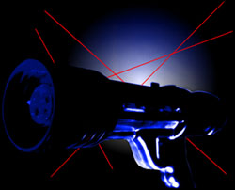

So this is not the first ELC event?

No. The first ELC event was held over the weekend of 27th and 28th January 2001 and proved to be a big success, with 14 teams attending from the UK and Holland. Over the two days, games were played at both Woking and Guildford Laser Quest centres.
After 14½ hours of frantic action the eventual winners proved to be “The Tribe Called Quest” from Guildford.
ELC 2001
Vital Statiistics
Total Number of Teams: 14
Total Number of Players: 126
Total Number of Games Played: 58
Total Game Time: 14.5 hours

The “Tribe” won the final by beating “The Wild Cards” from Eindhoven. The consolation plate was also won by a Guildford team (“The Freestylaz”) who narrowly defeated “Norfolk” from Coventry in a hard-fought match.

What about the future of the ELC?
With the experience of the first successful event behind us, the next chapter in the European Laser Quest Championships story is expected to be bigger and better. This year we will have the use of a single site for a longer period of time, which suits the teams better than having to adjust to the different arena layouts.
We are very pleased to be holding this year’s event at Europe’s newest Laser Quest site, Swindon. Opened to the public on February 8th of 2003, the site has already received very favourable reviews from those regular players who have visited and played there. With brand new equipment and a massive reception area, it is hoped that Swindon will be able to provide an excellent base for the tournament and make the 2003 event (scheduled to take place on the weekend of 26th and 27th April) a very tough act to follow.
The ultimate aim of the European Laser Quest Championships is to hold an annual event throughout those countries who have active Laser Quest communities, to provide the best in Europe with a focal point towards which they can work each year. Additionally it gives the players an excuse to meet up once a year, swap news and generally have a good time!
We hope that through the ELC we can encourage regular competition and some day reach a point whereby, along with the NAC, we can develop a regular intercontinental event. If in the process we can promote Laser Quest and, by association, the whole laser tag genre, through exposure in the media and through sponsorship deals, then all of the sites and teams stand to benefit from the influx of new members that this will undoubtedly create.
Vitally important for the future of the ELC, more European Laser Quest centres are being planned in the long term and a number of other sites that have been operating for some time are either refurbishing, upgrading or planning to do so in the very near future. This can only help to improve the legacy of Laser Quest and hopefully expand the population from which the ELC draws its participants.

Marketing the ELC

Presenting the ELC to the wider world

In the media
For this year’s event, we plan to ask all participating teams to send a brief press release to their local newspapers and radio stations a month before the event. The format of the press releases will be predefined by European Laser Quest Championships, although the individual teams will have space to provide details of their own involvement and their thoughts on the event.
Additionally in each participating country, a press release will be issued to national newspapers, radio stations and TV channels. This is ostensibly to provide contact details for the event and a brief summary of what the event is about, but again there will be freedom for the relevant contact to include information about their country’s participation in the event and any other relevant background information that they see fit.
The hope is that this may generate interest from a number of local sources throughout each country and therefore help the event into the spotlight in the locations in which teams are based. It is hoped that this will help to grab the attention of this wider audience and persuade them to give the Laser Quest experience a try. Again, the more people who try Laser Quest the better, as with more players sites will have the opportunity to attract more members.

On the internet
As befits a sport for a new era such as this, we will be aggressively marketing the ELC on the internet in the months and weeks leading up to the event. The previous ELC event had its own website, on which you can now see the results of that tournament (http://www.elc2001.co.uk/). The website for this year’s event is, accordingly, hosted at http://www.elc2003.co.uk/ and will be a central point of reference for details for teams entered, rules, tournament schedule and format. It will also contain details of press releases and sponsorship proposals and contain resources for visitors from these arenas to assist them in understanding the event.

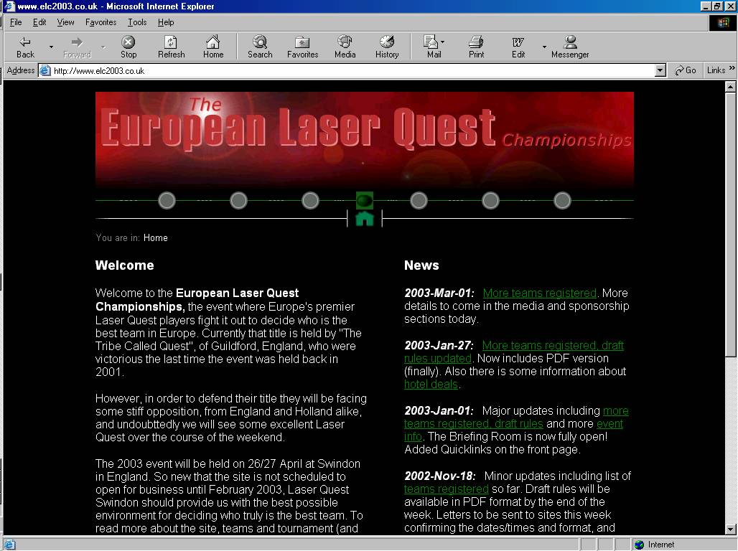www.elc2003.co.uk

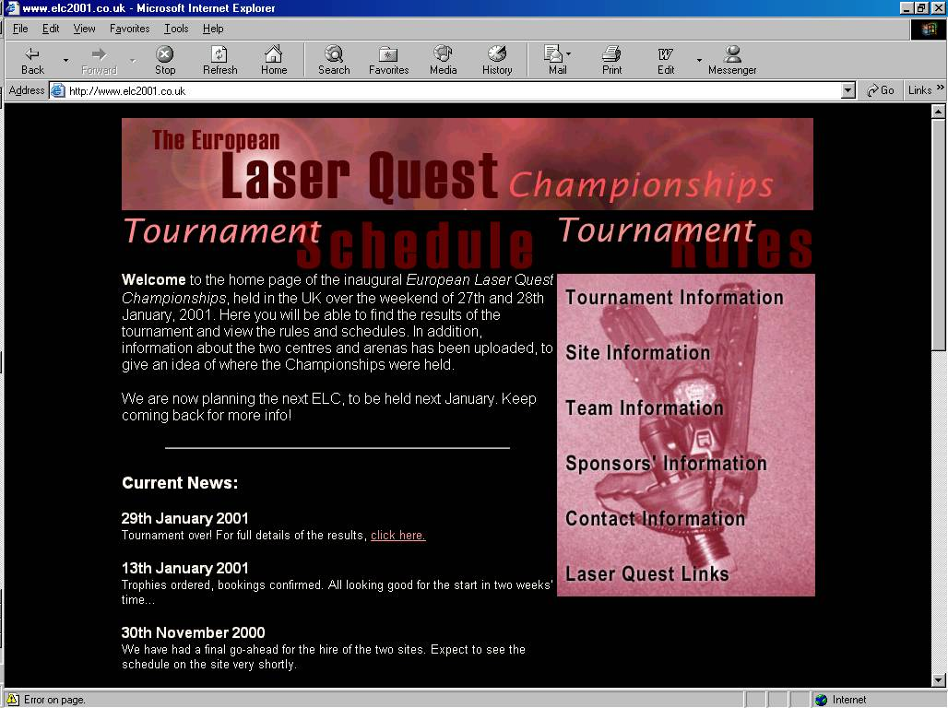www.elc2001.co.uk

We will also be pursuing other forms of internet-based advertising, as we hope that on-line versions of any media coverage would include a link to the event website. In addition to this, we will work with any sponsors for the event to ensure the widest possible audience. Additionally we will be promoting our URL on local websites around the areas sending teams to the event, and especially in and around the host town of Swindon. The main aim of this part of the marketing plan is to generate traffic for the ELC website and therefore raise awareness of the event, the sponsors and the Laser Quest name.

In the street
The Laser Quest centre in Swindon is located in the heart of the town, and we propose to make use of this extra marketing opportunity. We hope to be able to display banners bearing the name of the event and sponsors’ logos outside the building to generate greater awareness.
We have also to discuss with the centre itself regarding possible promotions that they would be willing to run in conjunction with our event. Again, the intention is to improve the visibility of Laser Quest as a competitive sport as well as a form of casual entertainment and a place to hold birthday parties and corporate events.

And ultimately?
Of course the best thing that could happen in terms of marketing would be to get a sizeable slot of coverage on a national or international television channel for the event. Laser Quest poses some interesting and unique challenges for filming, as not only does the arena have to be fairly dark in order that the players can see the laser beams and the lights on each others’ packs, but the game is, in every sense, three-dimensional.
Unlike other spectator sports such as football, tennis or rugby, there is no single focal point for the action; it is never focussed on a single place inside the arena. With 9 players per team you could quite possibly have six, seven or even more different action areas at any given time in a game. This is what makes the game so appealing to those who play competitively, though, and there could be no more fitting testament to the dedication, commitment and effort imparted by the players, not only during the competition but throughout the year, than widespread media coverage.

Sponsorship for the ELC

How you can help us take the ELC forward

So why should I be involved?
The European Laser Quest Championships is an event that we hope will attract media attention throughout the countries participating, to a greater or lesser extent. Building on the success of the first event in 2001, the event would appear to be an ideal vehicle for promoting Laser Quest as a recreational activity and also a competitive sport. Associating with the emergence of Laser Quest as a competitive sport in Europe will help to identify your organisation as a forward-thinking and visionary company, and will give you an important advantage in a sector of the leisure market that is set to expand over the coming years.
We are looking for a single sponsor, to have full title sponsorship rights for the event, preferably on a longer-term (3 to 5 year) basis. However, we realise that the economic environment at the present time is not ideally suited to engaging in such sponsorship commitments and therefore we are more than willing to consider any suggestions you may have around this topic. We welcome any interest in the event and are committed to being flexible in our sponsorship arrangements.

What do I get?
There are a number of things that an organisation could expect from an association with the European Laser Quest Championships;
- Local media coverage – in both the area around the event (Swindon, Wilts) and the areas from which the teams originate,
- Big exposure to the participants, who are mainly male in the age range 14 – 30,
- Exposure (through promotional t-shirts purchased and worn by participants, and the title sponsorship of the trophies) to a much wider audience of Laser Quest players, from birthday parties to corporate bookings to regular players,
- Banners outside Laser Quest in Swindon advertising the event, and the association your organisation has with it,
- Possible national media coverage of the event,
- Association with any internet links to the ELC website (as title sponsors),
- Prominent recognition on the ELC website for sponsors.

How can I help?
As an organising body we are of course interested in attracting as many teams and participants to the ELC in 2003 as possible. A major consideration and prohibiting factor for many teams will be the cost of attending the tournament. Those teams who do not come from the immediate area around the tournament venue will have to deal not only with the entry fee but also the cost of travel and accommodation.
We have little control over the cost of accommodation and travel for these teams, although we have negotiated a deal with the Holiday Inn Express, Swindon, for reduced rate rooms for that weekend. The main area in which we believe sponsorship can help, however, is in the entry fee for the tournament.
Obviously while the tournament is in progress, the host venue cannot be open to the public and will therefore be losing revenue. The hosts for this event have been very generous in the financial negotiations but that still leaves a cost for the tournament organisation. Currently the only source of income available to European Laser Quest Championships to cover this cost is the entry fee, paid by the teams themselves, and at £180 per team it is currently a considerable sum of money.
Sponsorship to the tune of £600 would enable us to reduce this sum by approximately 25%. This would be a great benefit to the players and teams involved, particularly for some teams who are made up almost exclusively of players under the age of 18, and for those teams who have had to travel from abroad or from far afield to get to the event.
Additionally our ultimate aim would be for us to have the financial resources to offer a monetary prize to the winning team. There is no more effective incentive for teams to take part in a tournament than the offer of prize money for the winners, and it would be just reward for the efforts that the winning team will have expended in becoming the European Champions. For this we would be looking to raise a multiple of £900, reflecting the fact that teams are made up of 9 people.
If you feel that your organisation is able to help us achieve our ultimate aims in bringing the ELC towards the mainstream of competitive sports events by helping to provide sponsorship, please contact us.
The next step

Timescales
We have tight timescales for ELC 2003, as you can no doubt imagine, as we are scheduled to run the event over the last weekend of April. However, we have outlined below the next steps in the critical path to the ELC.
Initial letter to participants: Complete end of December 2002
Detailed dialogue with host venue: Complete mid January 2003
Rules and tournament format: Complete end of February 2003
Registration of teams: Ongoing
Initial Press releases: Scheduled for end of March 2003
Follow-up press releases: Scheduled for 15th April 2003
Event starts: Saturday 26th April 2003

Contact details
If you feel that your organisation is able to help us achieve our ultimate aims in bringing the ELC into the mainstream of competitive sports events, either through helping us market our event to a wider audience, or through sponsorship of the event, then please contact us using one of the following methods:
e-mail: martin@lake-internet.co.uk
Post: European Laser Quest Championships
4 Windermere Close
Farnborough
Hampshire
GU14 0JZ
England
Telephone: +44 (20) 7015 6182 (daytime)
+44 (7958) 656706 (mobile)

